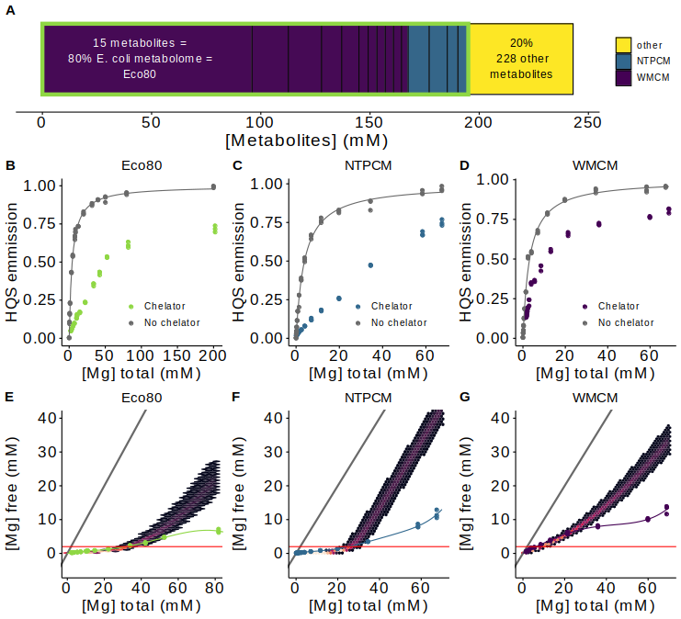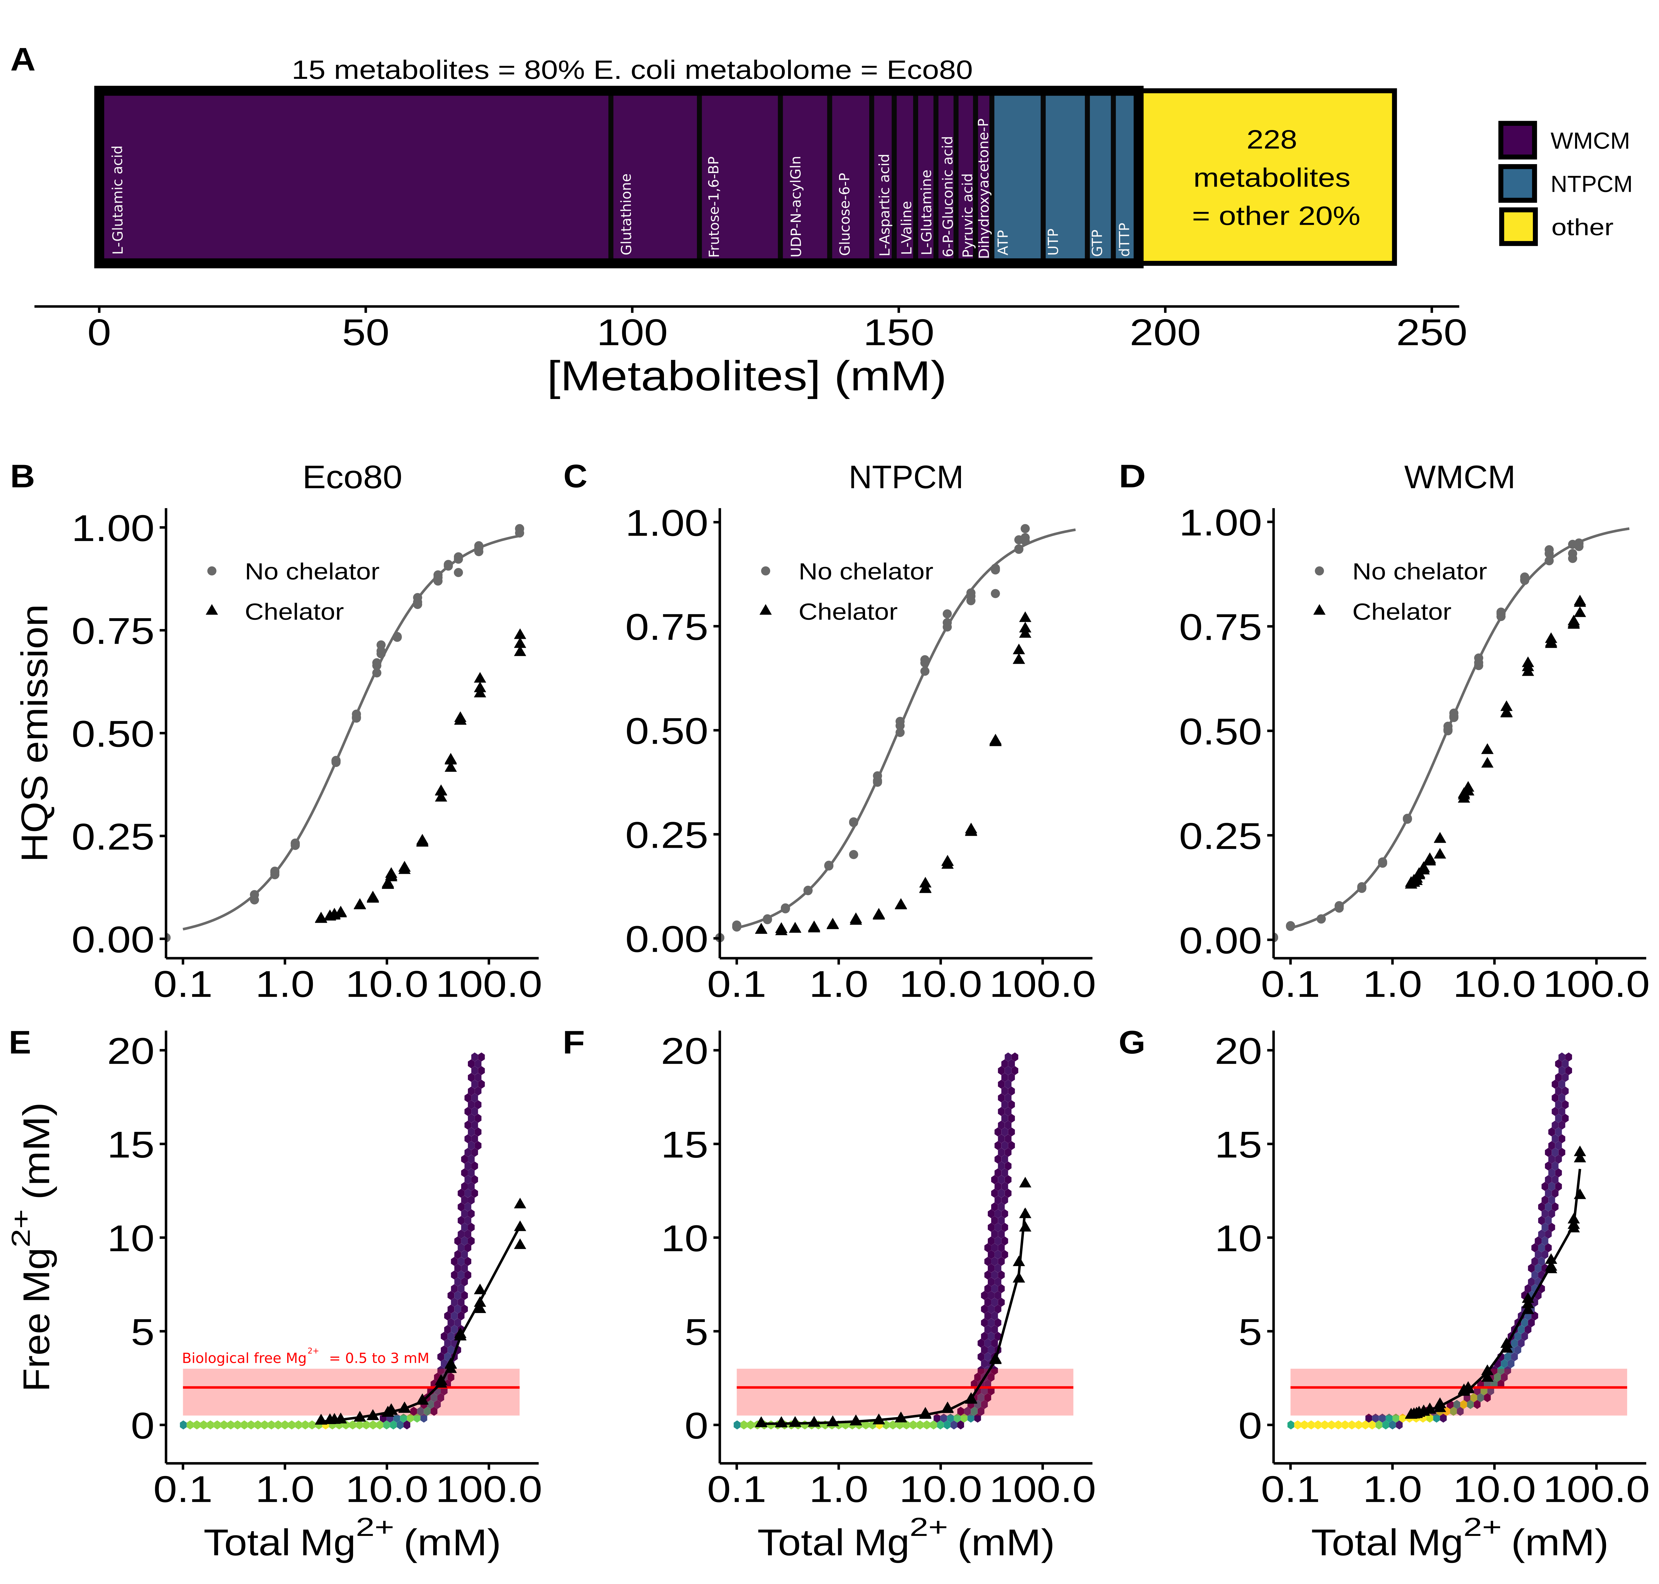**Figure 1** Analysis of Mg2+ speciation in *E. coli* metabolitemixtures. Eco80 contains **(A)** E. coli metabolome molar composition. Eco80 contains the 15 most abundant metabolites that comprise 80% of the *E. coli* metabolome. NTPCM contains four strong Mg2+ chelating NTPs, and WMCM contains 11 other weak Mg2+ binding metabolites. **(B-D)** Effect of Mg2+ on 8-hydroxyquinoline-5-sulphonic acid (HQS) emission with and without mixtures of metabolites that chelate Mg2+. Grey lines represent fits to determine the binding constant for Mg2+ and HQS in the absence of chelators. **(E-G)** Relationship between the total Mg2+ concentration and the free Mg2+ concentration with mixtures of metabolites that chelate Mg2+. The free Mg2+ concentration (y-axis) was calculated using HQS emission and the binding constant for Mg2+ and HQS. Hex bins represent a statistical simulation of 1000 virtual artificial cytoplasms based on experimental errors in KD determination, experimental errors in reagent concentrations, and single site binding. Triangle data points are free Mg2+ concentrations calculated using HQS emission. Black lines were generated using polynomial regression. The red shaded region is the biological free Mg2+ concentration, 0.5 to 3 mM. The red line is the approximate free Mg2+ concentration in *E. coli*.

**Table 1.** Eco80: the 15 most abundant metabolites which comprise 80% of the *E. coli* metabolome.

|  |  |  |  |
| --- | --- | --- | --- |
| Metabolite | Conc. (mM) | KD  (mM) | Chelation stength |
| ATP | 9.63 (0.963)a | 0.28 (0.01)b | NTPCM (Stronge) |
| UTP | 8.29  (0.829)a | 0.248 (0.004)b | NTPCM (Stronge) |
| GTP | 4.87  (0.487)a | 0.201  (0.007)b | NTPCM (Stronge) |
| dTTP | 4.62  (0.462)a | 0.160  (0.003)b | NTPCM (Stronge) |
| L-Glutamic acid | 96  (9.6)a | 520 (50)c | WMCM (Weake) |
| Glutathione | 16.6  (1.66)a | NAd | WMCM (Weake) |
| Fructose 1,6-bisphosphate | 15.2  (1.52)a | 5.9 (0.1)b | WMCM (Weake) |
| UDP-N-acytylglucosamine | 9.24  (0.924)a | 29 (2)b | WMCM (Weake) |
| Glucose 6-phosphate | 7.88  (0.788)a | 17.3 (0.2)b | WMCM (Weake) |
| L-Aspartic acid | 4.23  (0.423)a | 465 (12)c | WMCM (Weake) |
| L-Valine | 4.02  (0.402)a | NAd | WMCM (Weake) |
| L-Glutamine | 3.81  (0.381)a | NAd | WMCM (Weake) |
| 6-Phospho- gluconic acid | 3.77  (0.377)a | 14.4 (0.2)b | WMCM (Weake) |
| Pyruvic acid | 3.66  (0.366)a | 15.8 (0.9)c | WMCM (Weake) |
| Dihydroxyacetone phosphate | 3.06  (0.306)a | 20 (1)b | WMCM (Weake) |

Auncertainty propagated from uncertainties in reagent masses and volumes used during sample preparation. Extra significant digits included to avoid systematic rounding errors in the statistical model.

bDetermined at 37 °C with Isothermal titration calorimetry as measured in SI figure 1 and SI table 2. Error is the propagated standard error in the fit parameters.

cDetermined at 37 °C with HQS emission as measured in the SI figure 2 and SI table 3. Error is the propagated standard error in the fit parameters.

dNo binding observed as per SI Figure 2.

eMetabolites with KDs for Mg2+ less than 2 mM are considered strong Mg2+ chelators.

**SI Table 1.** Recipe for the Eco80 artificial cytoplasm (Add in later in word when I am formatting the tables)

SI Figure 1 Isothermal titration calorimetry (ITC) analysis of Mg2+ binding to metabolites in 240 mM NaCl 140 mM KCl 10 mM HEPES pH 7.0 at 37 °C. MgCl2 was titrated into metabolites and the power was monitored over time (Top panel). Heat of the injection was calculated by integrating the raw power curve, and the background heat of MgCl2 diltution, collected on buffer containing no metabolite, was subtracted to produce the isotherms in the bottom panels. Lines in bottom pannels represent fits to the Weismann isotherm equation to determine apparent association constants. **(A)** Adenosine triphosphate (ATP). **(B)** Uridine triphosphosphate (UTP). **(C)** Guanosine triphsophate (GTP). **(D)** deoxythymidine triphosphate (dTTP). **(E)** Fructose 1,6-bisphosphate. **(F)** Uridine diphosphate (UDP)-N-acytylglucosamine. **(G)** Glucose 6-phosphate. **(G)** 6-phosphogluconic acid. **(H)** phosphoenol pyruvate. **(G)** Ethylene diamine-tetracetic acid (EDTA). Thermodynamic values are found in SI table 2.

SI Table 2 Apparent binding constants determined with Isothermal titration calorimetry (ITC).

|  |  |  |  |  |  |
| --- | --- | --- | --- | --- | --- |
| Metabolite | Syringe (mM) | Cell (mM) | ΔH (kcal/mol) | K’ (M-1) | KD’ (mM-1) |
| ATP | 15 mM MgCl2a | 0.1 mM ATPa | 1.83 (0.04) | 3600 (200) | 0.28 (0.01) |
| UTP | 15 mM MgCl2a | 0.2 mM UTPa | 1.70 (0.01) | 4200 (70) | 0.248 (0.004) |
| GTP | 15 mM MgCl2a | 0.2 mM GTPa | 1.43 (0.02) | 5000 (200) | 0.201 (0.007) |
| dTTP | 15 mM MgCl2a | 0.2 mM dTTPa | 2.19 (0.02) | 6300 (300) | 0.160 (0.003) |
| Fructose 1,6-BP | 100 mM MgCl2a | 5.0 mM Fructose 1,6-BPa | 0.414 (0.004) | 169 (4) | 5.9 (0.1) |
| UDP-GlcNAC | 100 mM MgCl2a | 5.0 mM UDP-GlcNAC | 0.57 (0.02) | 34 (2) | 29 (2) |
| Glucose 6-P | 100 mM MgCl2a | 5.0 mM Glucose 6-Pa | 0.555 (0.003) | 57.9 (0.7) | 17.3 (0.2) |
| 6-P-gluconic acid | 100 mM MgCl2a | 5.0 mM 6-P-gluconic acida | 0.662 (0.005) | 70 (1) | 14.4 (0.2) |
| Dihydroxyacetone phosphate | 100 mM MgCl2a | 5.0 mM dihydroxy-acetone phosphatea | 0.50 (0.01) | 51 (3) | 20 (1) |
| EDTA | 6 mM MgCl2a | 1.5 mM EDTA 1.0 mM MgCl2a,b | 2.85 (0.04) | 220,000 (30,000) | 0.0045 (0.0006) |

a240 mM NaCl 140 mM KCl 10 mM HEPES pH 7.0 at 37 °C

bMg2+ and EDTA were incorporated into the cell in order to sequester trace tight binding metal ions and thereby negate their contribution to ITC signal.

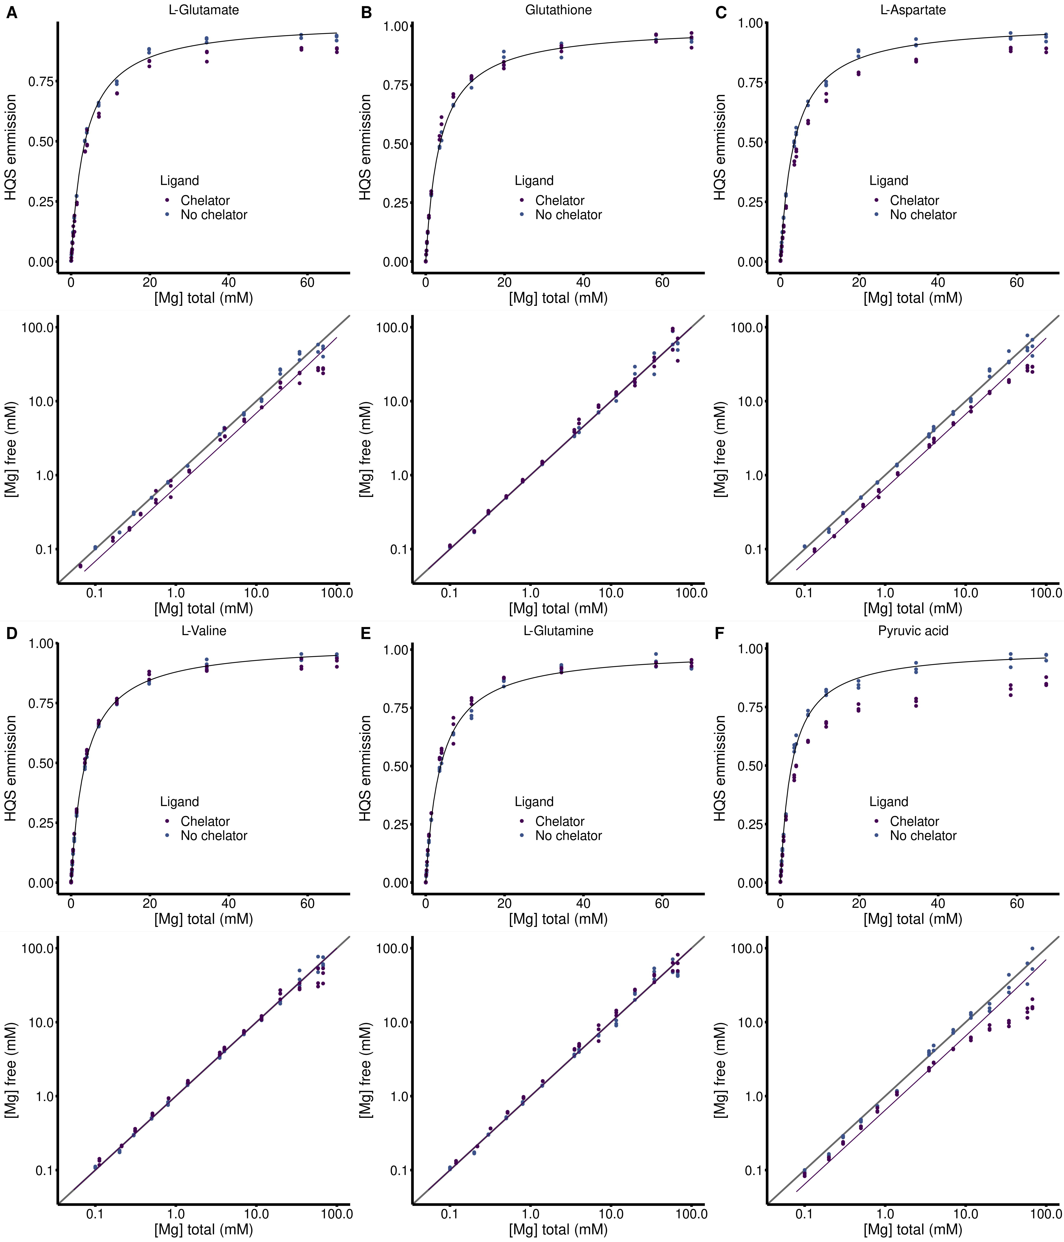**SI Figure 2** HQS analysis of Mg2+ binding to metabolites in 240 mM NaCl 140 mM KCl 20 mM MOPS 0.01 mM EDTA 0.001% SDS pH 7.0. (Top panels) Dependence of HQS emission on the total concentration of MgCl2 in the presence and absence of a metabolite chelators. Black lines represent a fit to SI equation 1 to determine the Fmax, Fmin, and KHQS. (Bottom panels) Dependence of the free Mg2+ concentration on the total concentration of MgCl2 in the presence and absence of a metabolite chelators. Grey lines represent where the free Mg2+ concentration equals the total concentration of MgCl2, Purple lines represent a fit to SI equation 4 to determine the association constant between HQS and a chelator. **(A)** 240 mM L-glutamate. **(B)** 194 Glutathione. **(C)** 240 mM L-aspartate. **(D)** 240 mM L-valine. **(E)** 240 mM L-glutamine. **(F)** 5 mM pyruvic acid.

SI Table 3 Apparent binding constants determined with HQS emission. Fmax, Fmin, and KHQS are determined by fitting HQS emission in the absence of chelators and used to calculate the free Mg2+ concentration in each sample. Metabolite binding constants, K’ and KD’. are determined by fitting the relationship between the free Mg2+ concentration and the total MgCl2 concentration using SI Equation 4.

|  |  |  |  |  |  |
| --- | --- | --- | --- | --- | --- |
| Metabolite | Fmax | Fmin | KHQS (mM-1) | K’ (mM-1) | KD’ (mM-1) |
| L-Glutamic acid | 187,000 (1000) | 0 (810) | 0.281 (0.008) | 0.0019 (0.0002) | 520 (50) |
| Glutathione | 182,000 (1000) | 592 (750) | 0.279 (0.007) | NAc | NAc |
| L-Aspartic acid | 196,000 (1000) | 0 (820) | 0.283 (0.007) | 0.0021 (0.0001) | 465 (12) |
| L-Valine | 188,200 (800) | 495 (580) | 0.274 (0.005) | NAc | NAc |
| L-Glutamine | 190,000 (1400) | 516 (110) | 0.27 (0.01) | NAc | NAc |
| Pyruvic acid | 188,000 (1500) | 0 (1300) | 0.35 (0.01) | 0.063 (0.003) | 15.8 (0.9) |

cNo binding observed as per SI Figure 2

**SI Table 3.** HQS fits in the absence of chelators, used to determine free Mg2+ concentrations. Fmax, Fmin, and KHQS are determined by fitting HQS emission in the absence of chelators and used to calculate the free Mg2+ concentration in each sample.

|  |  |  |  |
| --- | --- | --- | --- |
| Metabolite | Fmax | Fmin | KHQS (mM-1) |
| Eco80 | 185,100 (800) | 124 (1000) | 0.239 (0.005) |
| NTPCM | 187,000 (1500) | 436 (1000) | 0.26 (0.01) |
| WMCM | 179,000 (1600) | 0 (1400) | 0.32 (0.01) |

Table 2. Total Mg2+ concentrations used to obtain 2 mM free Mg2+ in artificial cytoplasms.

|  |  |  |  |
| --- | --- | --- | --- |
| Condition | Total [Mg2+] (mM) | Chelated [Mg2+] (mM) | Free [Mg2+] (mM) |
| Eco80 | 31.6 | 29.6 | 2.0 |
| NTPCM | 25.0 | 23 | 2.0 |
| WMCM | 6.4 | 4.5 | 2.0 |

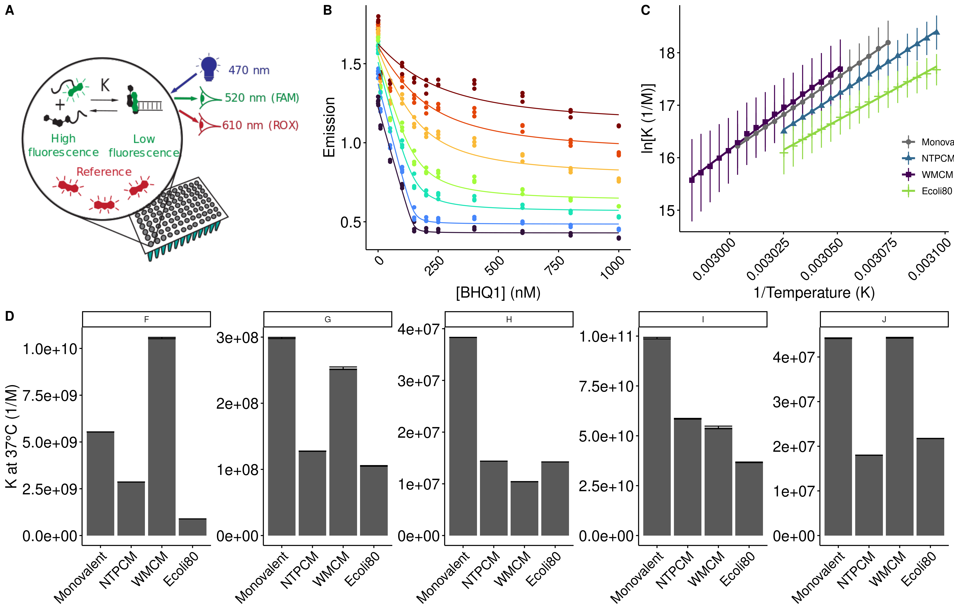**Figure 2** *E. coli* metabolite and Mg2+ mixtures destabilize RNA secondary structure.

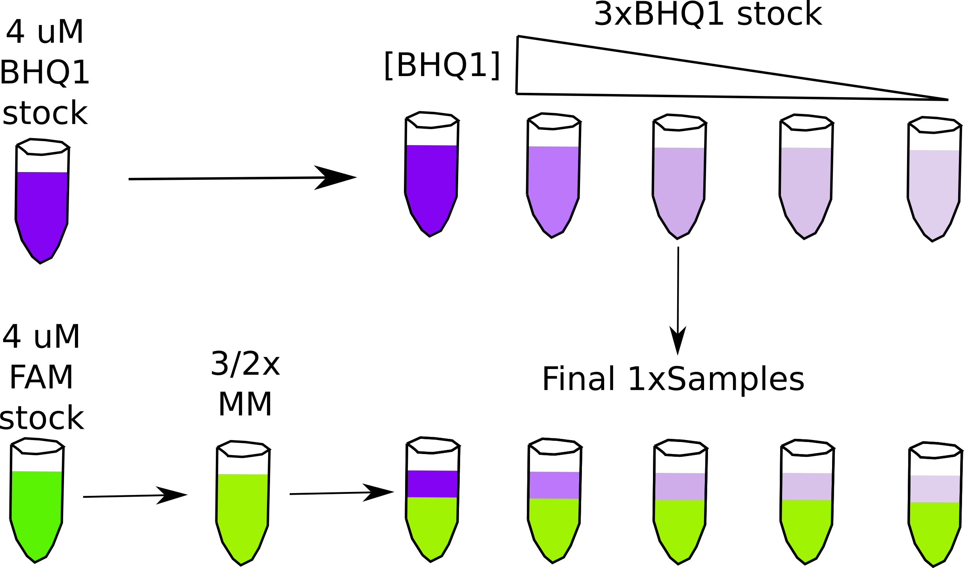

**SI figure 3** *E. coli* metabolite and Mg2+ mixtures destabilize RNA secondary structure.

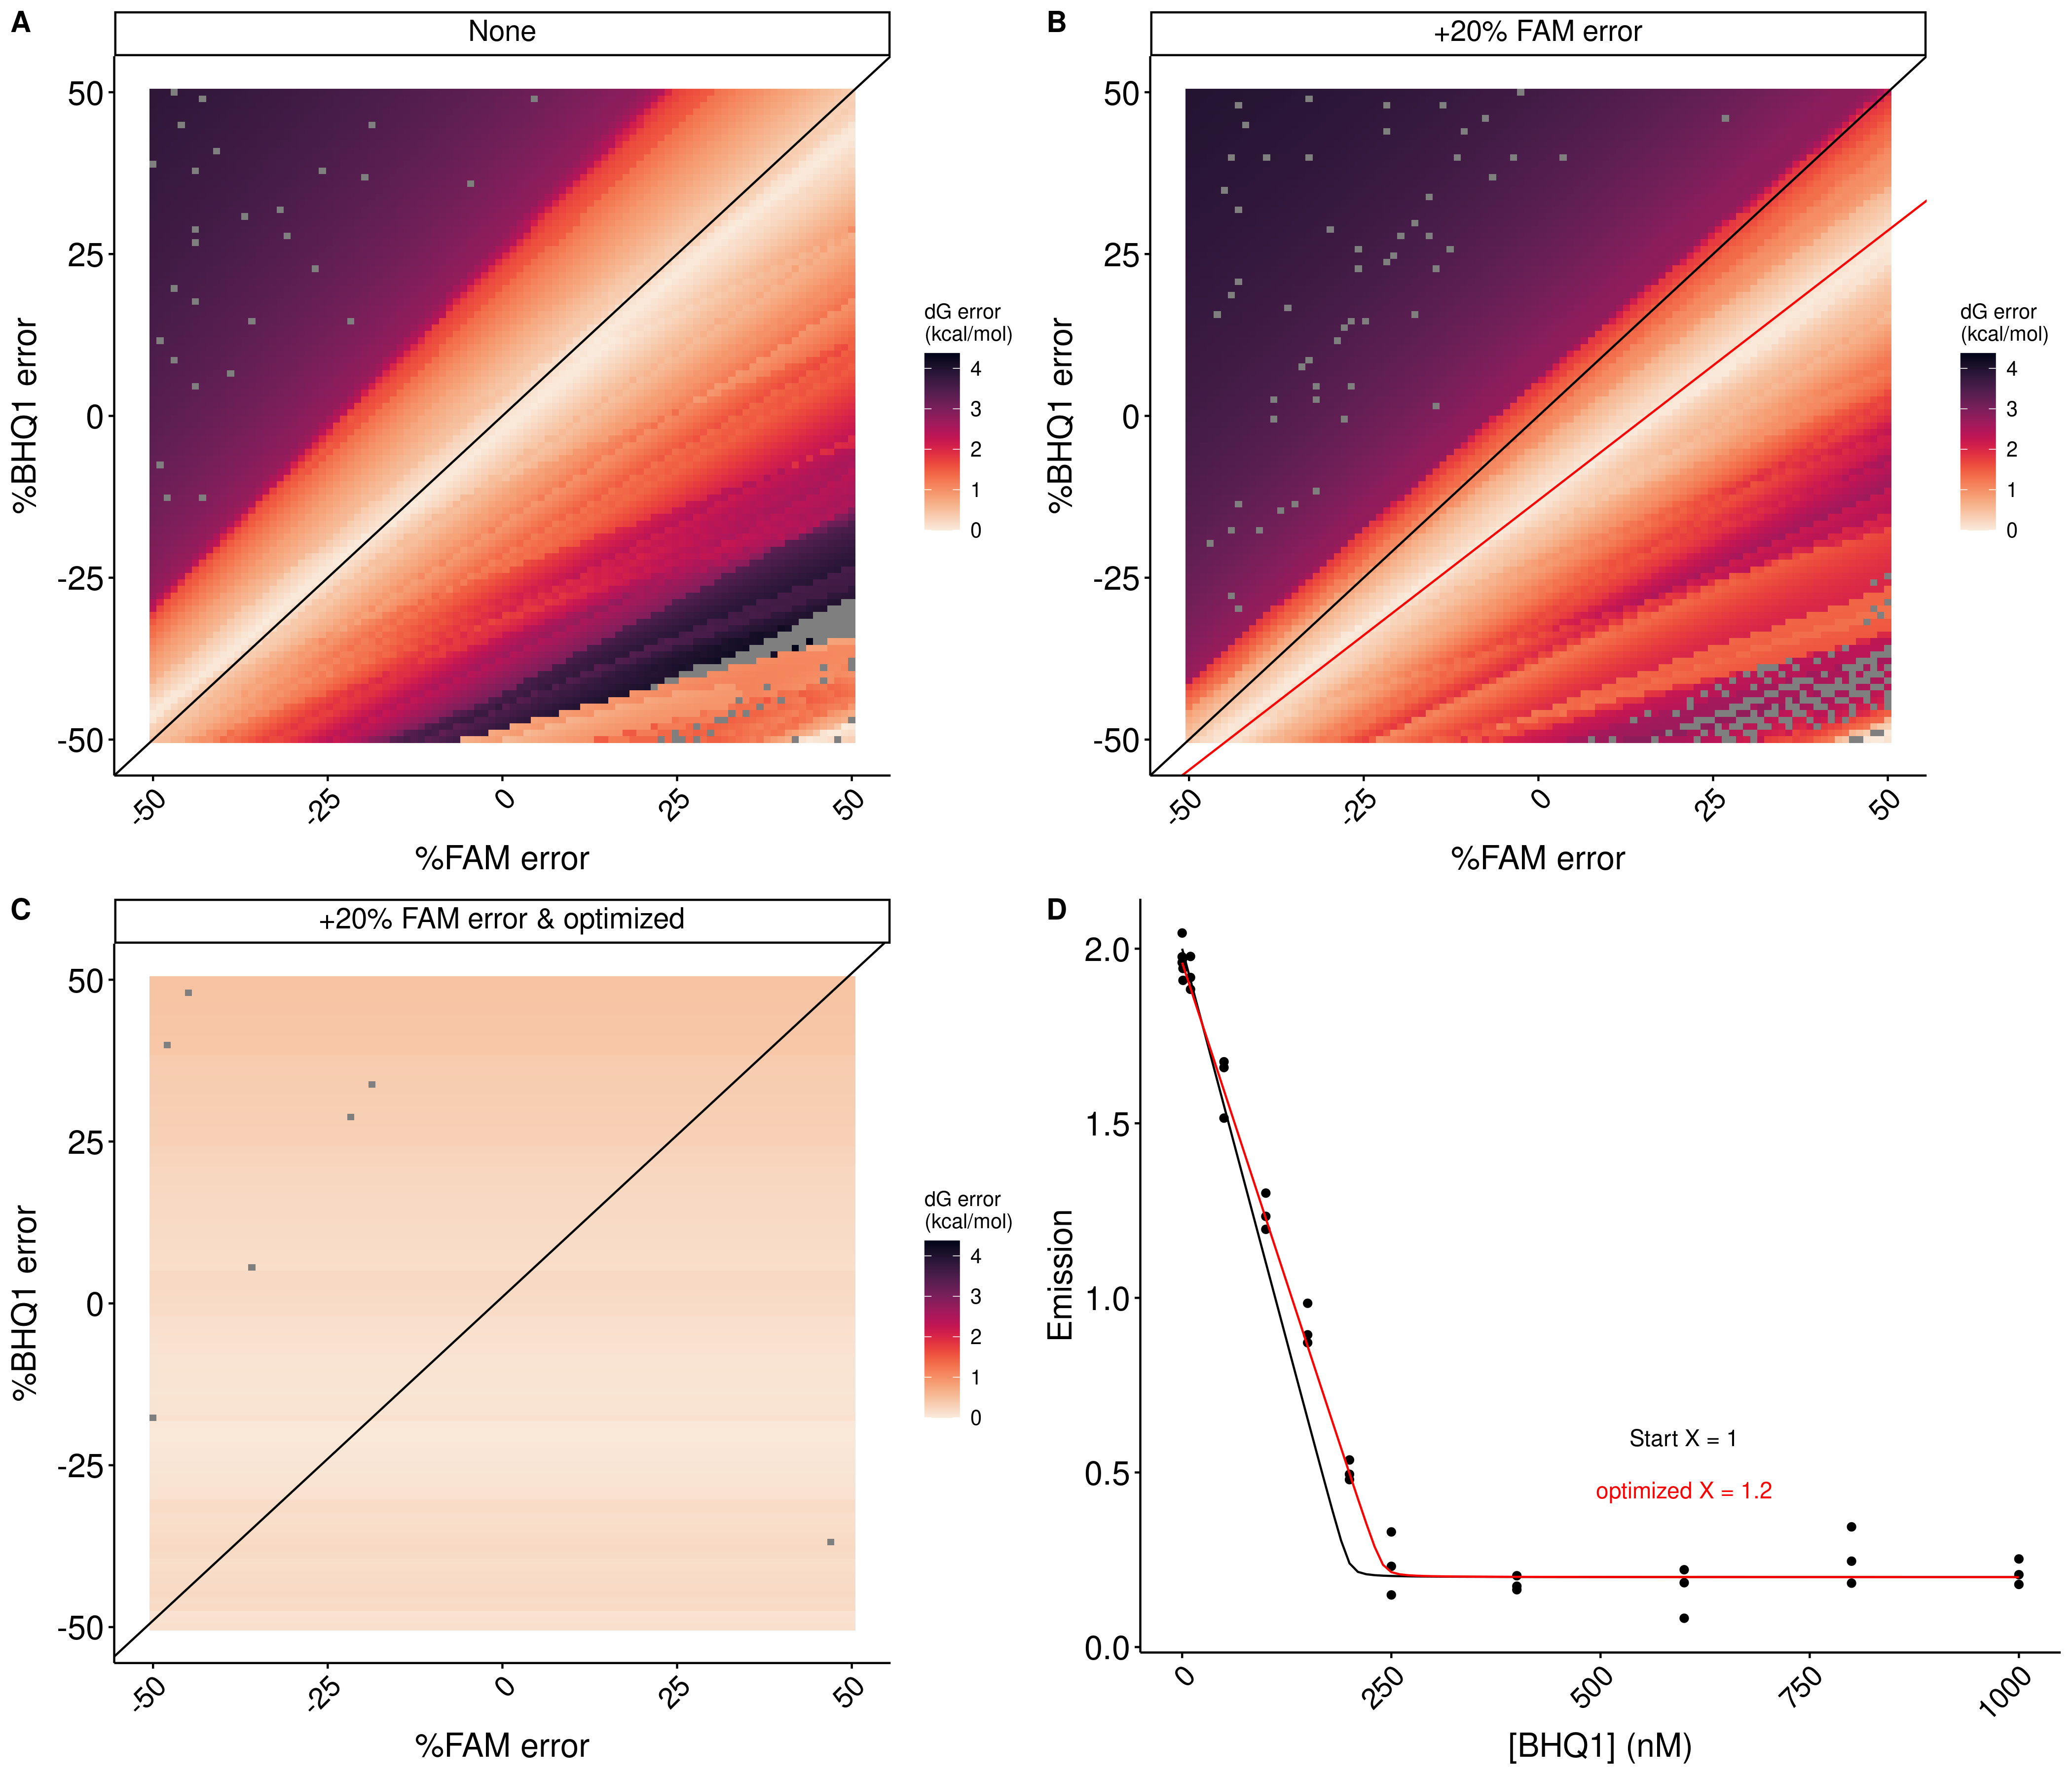

**SI figure 4** *E. coli* metabolite and Mg2+ mixtures destabilize RNA secondary structure.

Table 3. Stability of RNA helices in *E. coli* **metabolite mixtures.**

|  |  |  |  |  |  |  |  |
| --- | --- | --- | --- | --- | --- | --- | --- |
| Helix | Sequence (5'-FAM/ BHQ1-3') | AU  content | Condition | ΔH (kcal/mol) | ΔS (cal/mol/K) | ΔG (kcal/mol) | ΔΔG (kcal/mol) |
| 1 | CGCAUCCU/AGGAUGCG | 0.38 | 2 mM free | -55.9 (0.2) | -136.0 (0.7) | -13.82 (0.01) |  |
| NTPCM | -52.2 (0.4) | -125 (1) | -13.41 (0.02) | 0.41 (0.02) |
| WMCM | -61.4 (0.8) | -152 (2) | -14.22 (0.05) | -0.40 (0.05) |
| Ecoli80 | -44.5 (0.7) | -102 (2) | -12.70 (0.04) | 1.13 (0.04) |
| 2 | CCAUAUCA/UGAUAUGG | 0.63 | 2 mM free | -53.4 (1.0) | -133 (3) | -12.02 (0.04) |  |
| NTPCM | -42.9 (0.5) | -101 (1) | -11.50 (0.02) | 0.52 (0.04) |
| WMCM | -53 (2) | -132 (7) | -11.9 (0.1) | 0.10 (0.01) |
| Ecoli80 | -57 (2) | -146 (5) | -11.38 (0.05) | 0.64 (0.06) |
| 3 | CCAUAUUA/UAAUAUGG | 0.75 | 2 mM free | -53.5 (0.4) | -137 (1) | -10.76 (0.01) |  |
| NTPCM | -45.0 (0.2) | -112.5 (0.5) | -10.158 (0.002) | 0.60 (0.01) |
| WMCM | -43 (2) | -107 (5) | -9.94 (0.02) | 0.80 (0.02) |
| Ecoli80 | -41.3 (0.2) | -100.4 (0.7) | -10.15 (0.01) | 0.61 (0.01) |
| 4 | CGGAUGGC/GCCAUCCG | 0.25 | 2 mM free | -71.1 (0.8) | -179 (2) | -15.6 (0.06) |  |
| NTPCM | -70.4 (0.6) | -177 (2) | -15.28 (0.05) | 0.32 (0.08) |
| WMCM | -65.5 (2) | -162 (7) | -15.2 (0.2) | 0.4 (0.2) |
| Ecoli80 | -69.7 (0.8) | -176 (3) | -14.0 (0.1) | 0.61 (0.08) |
| 5 | CGUAUGUA/UACAUACG | 0.63 | 2 mM free | -63.2 (0.9) | -169 (3) | -10.85 (0.02) |  |
| NTPCM | -59 (1) | -157 (4) | -10.30 (0.01) | 0.55 (0.02) |
| WMCM | -67 (1) | -180 (3) | -10.85 (0.02) | 0.00 (0.03) |
| Ecoli80 | -61 (1) | -164 (3) | -10.41 (0.01) | 0.44 (0.02) |

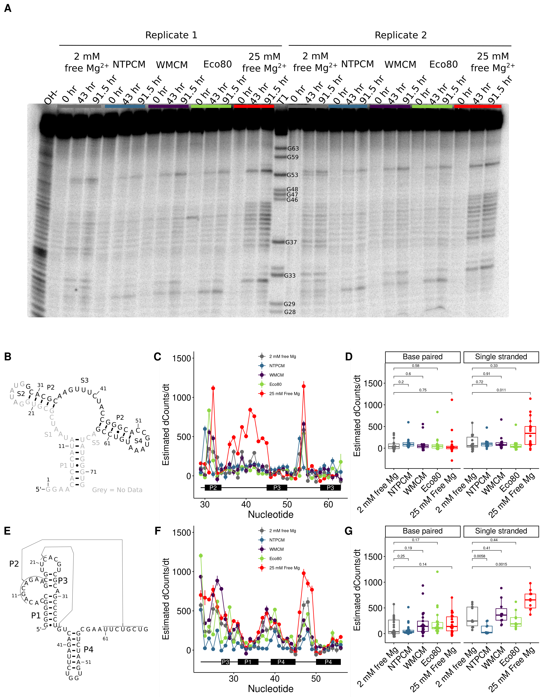

**Figure 3** *E. coli* metabolite and Mg2+ mixtures stabilize the chemical structure of RNA. **(A)** Raw degradation assay gel image for the Guanine riboswitch aptamer incubated in artificial cytoplasms at 37 °C and pH 7. The OH- lane contains a hydrolysis ladder which cleaves after every nucleotide and T1 contains the RNA treated with T1 ribonuclease which cleaves after every G. Enough Mg2+ was added to each artificial cytoplasm to have 2 mM Mg2+  as determined in Figure 1. **(B)** Secondary structure of the guanine riboswitch aptamer. **(C)** Estimated increase in counts as a function of time at each residue in different solution conditions as a function of location in the RNA. **(D)** Estimated increase in counts as a function of time in different conditions grouped by paired and unpaired bases. Significance was determined using a student’s t-test. **(E)** Secondary structure of the cleaved human CPEB3 HDV ribozyme. **(C)** Estimated increase in counts as a function of time at each residue in different solution conditions as a function of location in the RNA. **(D)** Estimated increase in counts as a function of time in different conditions grouped by paired and unpaired bases. Significance was determined using a student’s t-test.

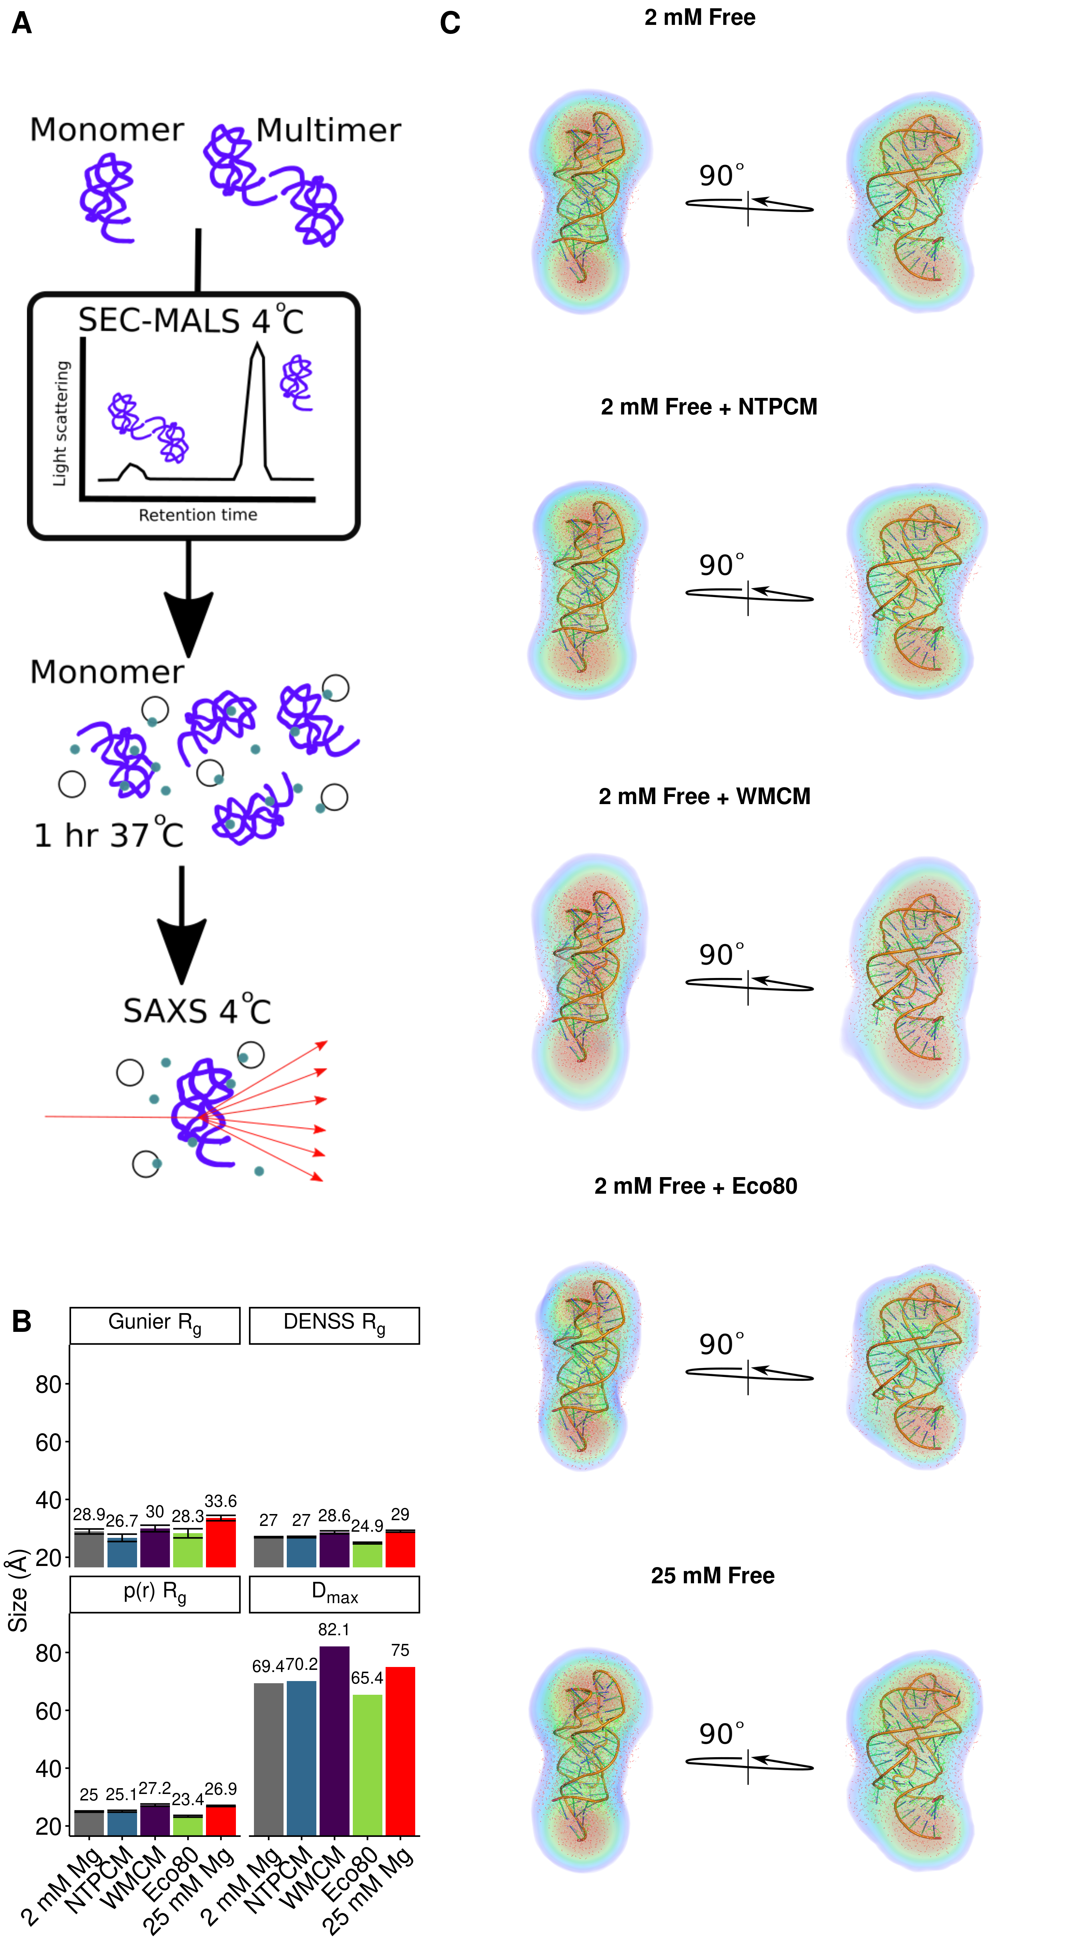

**Figure 4** *E. coli* metabolite and Mg2+ mixtures increase functional RNA compactness.